**CSE 115 Lab on Strings and 1D Array – Ara2**

1. **Passing array as an argument of a function:**

#include <stdio.h>

double getAverage(int arr [], int size){

int i;  
 double avg, sum=0;  
 for (i=0; i< size; i++){

sum += arr[i] ;

}  
 avg = sum/size;

return avg;  
}

void main()

{

int balance [5] = {1000, 2, 3, 17, 50};  
 double avg;

avg = getAverage( balance , 5 );

printf(“Average is: %f ”, avg);

}

1. **Passing string as an argument of a function and update that string within the function:**

#include <stdio.h>

#include<ctype.h>

#define SIZE 100

void changeCase(char s[])

{

int i;

for (i = 0; s[i] != NULL; i++)

{

if (isupper(s[i]))

s[i] = tolower(s[i]);

else if (islower(s[i]))

s[i] = toupper(s[i]);

}

}

void main ()

{

char str[SIZE];

printf ("Enter a string of length < %d : ", SIZE);

gets(str);

changeCase(str);

puts(str);

}

**Exercise:**

1. **Write a C program that counts the number of vowels in an input string.**
2. **Write a C program that reads a string, create a new string containing all the characters the input string except the vowels in it, and then prints the new string.**

**Sample input/output:**

Enter a string: **Hello how are you?**

Output string: Hll hw r y?

1. **Write a C program to print all unique letters in an input string.**

**Sample input/output:**

Enter a string: **Hello how are you?**

Unique letters in the input string (ignoring differences between lowercase & uppercase letters):

a, e, h, l, o, r, u, w, y

1. **Write a program that reads a string from user and then prints the number of times different letters appear in that string.**

**Sample input/output:**

Enter a string: **Hello how are you?**

Frequencies of letters in the input string:

a/A: 1, e/E: 2, h/H: 2, l/L: 2, o/O: 3, r/R: 1, u/U: 1, w/W: 1, y/Y: 1,

**Assignment:**

1. **Write a C program that deletes all duplicate letters from an input string.**
2. **Write a C program to put even and odd elements of an array in two separate arrays and show them.**

**Sample input/output:**

Input size of the array: **10**  
Input elements in array: **0 1 2 3 4 5 6 7 8 9**  
Even elements in array: 0 2 4 6 8  
Odd elements in array: 1 3 5 7 9

1. **Write a function that searches for a character in a string. The function should print true if found, otherwise print false.**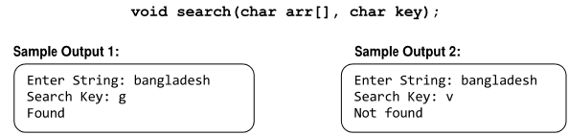
2. **Write a function that returns the number of times a value appears in an array.**